Q3
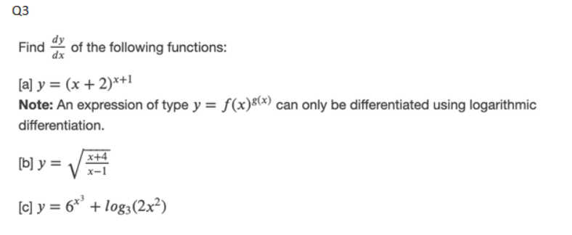
a)
$$y ={\left(x+2\right)}^{x+1}$$
It can be re-written as
$$y=e^{\left(x+1\right)\ln{(x+2)}}$$
So,
$$\frac{dy}{dx}=\frac{d}{dx}\left[e^{\left(x+1\right)\ln\left(x+2\right)}\right]$$
$$\frac{dy}{dx}=e^{\left(x+1\right)\ln\left(x+2\right)}×\frac{d}{dx}\left[\left(x+1\right)\ln\left(x+2\right)\right]$$
$$\frac{dy}{dx}=e^{\left(x+1\right)\ln\left(x+2\right)}×[\ln\left(x+2\right)×\frac{d}{dx}\left(x+1\right)+\left(x+1\right)×\frac{d}{dx}\left(\ln\left(x+2\right)\right)$$
$$\frac{dy}{dx}=e^{\left(x+1\right)\ln\left(x+2\right)}×\left[\ln\left(x+2\right)+\frac{x+1}{x+2}\right]$$

b)
$$y=\sqrt{\frac{x+4}{x-1}}$$
$$\frac{dy}{dx}=\frac{1}{2 \sqrt{\frac{x+4}{x-1}}}×\frac{d}{dx}\left[\frac{x+4}{x-1}\right]$$
$$\frac{dy}{dx}=\frac{1}{2 \sqrt{\frac{x+4}{x-1}}}×\left[\frac{\left(x-1\right)×\frac{d}{dx}\left(x+4\right)+\left(x+4\right)×\frac{d}{dx}\left(x-1\right) }{{\left(x-1\right)}^{2}} \right]$$
$$\frac{dy}{dx}=\frac{1}{2 \sqrt{\frac{x+4}{x-1}}}×\left[\frac{-5 }{{\left(x-1\right)}^{2}} \right]$$
$$\frac{dy}{dx}= -\frac{5}{2 \sqrt{x+4} {\left(x-1\right)}^{\frac{3}{2}}}$$

c)
$$y=6^{x^{3}}+\log_{3}\left(2x^{2}\right)$$
$$\frac{dy}{dx}=\frac{d}{dx}\left(6^{x^{3}}\right)+\frac{d}{dx}\left(\log_{3}\left(2x^{2}\right)\right)$$
$$\frac{dy}{dx}=\left[6^{x^{3}}×\ln{6}×\frac{d}{dx}\left(x^{3}\right) \right]+\left[\frac{1}{\ln{3}}×\frac{1}{2x^{2}}×\frac{d}{dx}\left(2x^{2}\right)\right]$$
$$\frac{dy}{dx}=3x^{2}\ln{6} 6^{x^{3}}+\frac{2}{x\ln{3}}$$

4.
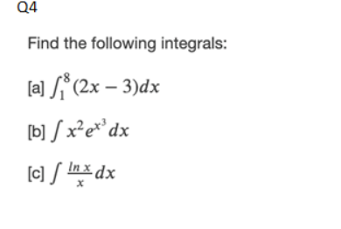
a)
$$\int_{1}^{8}{ \left(2x-3\right)dx}$$
$$={\left[ x^{2}-3x\right]}_{1}^{8}$$
$$=\left[40-\left(-2\right)\right]=42$$

b)
$$\int{x^{2}e^{x^{3}}dx}$$
Let us assume $x^{3}=t→3x^{2} dx=dt→x^{2}dx =\frac{dt}{3}$
Putting in integration, we get
$$\int{\frac{e^{t}}{3}dt }=\frac{1}{3}e^{t}+C$$
Putting the value of t
$$=\frac{1}{3}e^{x^{3}}+C$$
c)
$$\int{\frac{\ln{x}}{x}dx }$$
Let us assume $\ln{x}=t→\frac{1}{x}dx =dt$
Putting in integration equation we get ,
$$\int{t dt }=\frac{t^{2}}{2}+C$$
Put the value of t
$$=\frac{{\left(\ln{x}\right)}^{2}}{2}+C$$

Q5
The demand function is given by
$$10p – 10q+pq=300$$
We are given $\frac{dp}{dt}=10 cents/ day$
We are required to find $\frac{dq}{dt}$
Differentiating the demand function, we get
$$10\frac{dp}{dt}-10\frac{dq}{dt}+\left[p×\frac{dq}{dt}+q×\frac{dp}{dt}\right]=0$$
Now we are given the When p = 20 , q = 10
Putting in above equation
$$→ \left(10×10 \right)-\left(10×\frac{dq}{dt}\right)+\left[ 20×\frac{dq}{dt}+10×20 \right]=0$$
$$→100-10\frac{dq}{dt}+\left[ 20\frac{dq}{dt}+200\right]=0$$
$$→\frac{10dq}{dt}= -300$$
$$\frac{dq}{dt}= -30 bottles per day$$

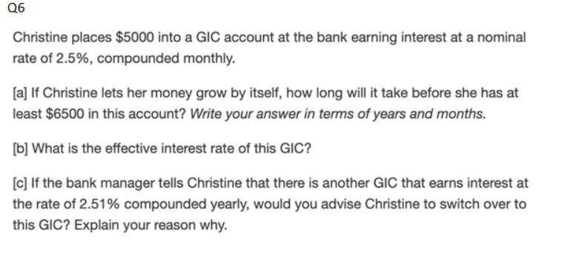$Compound Interest is given by$
$$A=P {\left(1+\frac{r}{n}\right)}^{tn}$$
$$a)$$
We are given $A=\$6500$
Putting in equation
$$6500=5000 {\left(1+\frac{0.025}{12}\right)}^{t*12}$$
Solving we get
$$t=10.5→10 years and 6 months$$

b)
effective interest rate is given by
$$r_{eff}={\left(1+r\right)}^{t}-1$$
Putting values, we get
$$r_{eff} ={\left(1+0.025\right)}^{10.5}-1=28.37\%$$

c)
To make a decision let us calculate effective rate for 2.51% and compounded yearly
$${r_{eff}}_{1}={\left(1+r\right)}^{10.5}-1$$
$$r_{eff_{1}}=28.13\%$$
Which is less than compounded monthly.
Hence I will advise Christine not to switch over to This GIC. Because effective interest rate is less hence less interest.

Q8
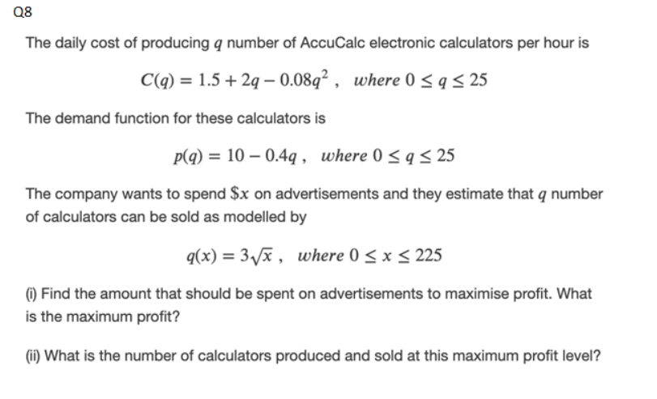

Profit is given by
Profit = Revenue – cost
Revenue = $p\left(q\right)×q\left(x\right)$
Putting values
$$revenue = \left[10-0.4q\right]×q\left(x\right)=\left[10-1.2\sqrt{x} \right]×3\sqrt{x}=30\sqrt{x}-3.6x$$
$$Cost=1.5+2q-0.08q^{2}+x =1.5+ 6\sqrt{x} -0.072x+x$$
$$Cost=1.5+6\sqrt{x}+0.928x$$
Profit $=30\sqrt{x}-3.6 x -1.5-6\sqrt{x}-0.928x→24\sqrt{x}-4.528x-1.5$
To maximize profit we differentiate
$$→\frac{d}{dx}\left[24\sqrt{x}-4.528x-1.5\right]=0$$
Solving we get
$$\frac{12}{\sqrt{x}}-4.528=0→x=7.023$$
The company should spend $7.02 dollars for advertising maximum profit
Maximum profit is given by
$$Profit at x=7.02$$
$$Profit =24\sqrt{x}-4.528x-1.5 at x=7.02$$
$$Profit =\$ 30.30$$

ii.
Number of calculators sold $q=3 \sqrt{x}=21.07$
Number of calculators produced
$$p\left(q\right)=10-0.4q→10-8.43=1.57$$

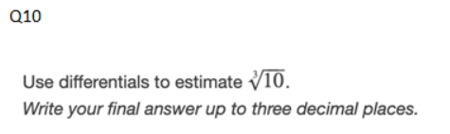
We know that
$$f\left(x+Δx\right)\sim f\left(x\right)+dy=f\left(x\right)+f^{'}\left(x\right)dx$$
$$f\left(x\right)=x^{\frac{1}{3}}$$
$$f^{'}\left(x\right)=\frac{1}{3}x^{-\frac{2}{3}}$$
$$f\left(x\right)={10}^{\frac{1}{3}}={\left(8+2\right)}^{\frac{1}{3}}$$
$$dx=2$$
$$f\left(10\right)=f(8+2)=f\left(8\right)+f^{'}\left(8\right)×2$$
$f\left(10\right)={\left(8\right)}^{\frac{1}{3}}+\left[\frac{1}{3}{\left(8\right)}^{-\frac{2}{3}}×2 \right]$
$$f\left(10\right)=2+\left[\frac{1}{12}×2\right]=2+\frac{1}{6}=2.167$$

